 Report Request Form
Suggested Report Name
Requester
Contact Phone
Documenter (person completing this form)
Purpose/Business Need
of this Report.
(Include estimated value/savings report will generate. e.g. “will save Returns department approx. X hours/week by not having to look up dozens of individual orders in SOP.”)

Is there an existing report that exists that can be modified to meet this need? Y / N

If yes, what is the name of the report?

Report Users (Which departments should have access?):

Input Parameters (What will the user enter to run the report? date range, market, division etc. Some reports do not need input from the end users such as a report that lists all open orders):

Will this report be exported to Excel the majority of the time? Y / N
(note: columns in the report will be sortable with both ascending and descending options without needing to export to Excel)

Additional Notes/Comments:

Mock-up: A simple mock-up with a few rows of dummy data is required (see example below). It will ensure you get the general appearance that is most useful to you. Be sure to send the mock-up along with this report request form to ithelpdesk@speedwaymotors.com

EXAMPLE MOCK-UP:
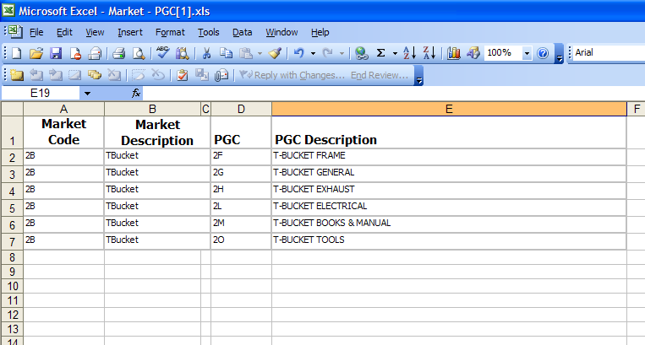

The sections below are needed only if the mock-up doesn’t display all requirements:

Default sort preferences (part number, most recent date first, etc): __________________

Grouping: ____________________ Level of drill-down (if any): ___________________

Formulas for any manual calculations:
________________________________
________________________________
________________________________
________________________________
________________________________
________________________________

What level(s) are totals/sub-totals needed (if at all):
________________________________
________________________________
________________________________
________________________________
________________________________
________________________________

